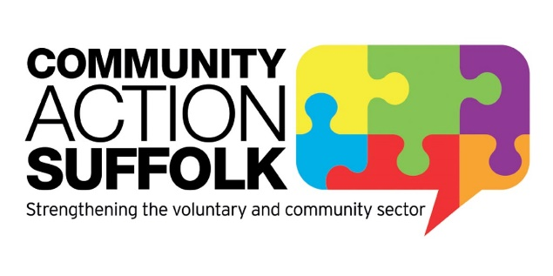

Brightspace
160 Hadleigh Road
Ipswich
Suffolk
IP2 0HH

T: 01473 345302
chris.abraham@communityactionsuffolk.org.uk

Stansfield Parish Council
By email

20th October 2022

Dear Stansfield Parish Councillors,

Thank you for your letter dated 03.10.22 outlining areas of dissatisfaction with Community Action Suffolk’s service for a Housing Needs Survey for Stansfield and a request for a full refund.

We have worked very hard with Stansfield Parish Council to overcome the issues raised throughout the process. Following our last meeting in July 2022 we believe we offered 2 good and fair options.

I have responded below to the numbered bullet point issues as raised in your letter to confirm again our position, although we have addressed all of these in previous communications over the many months.

- We listen to parishes to understand what information they want to obtain from a survey, then provide guidance to develop questions which will gather the necessary data to enable a housing needs report to be produced. The guidance we provide is from our 19 years’ experience and knowledge in this area of work.
- We would not have promised at any point that data from additional forms distributed by SPC could be separated and interrogated separately due to the nature of the survey being anonymous.
- CAS did not distribute any surveys to residents, neither original, nor additional copies.
- The Copyright for the report is clearly set out in section 6 of the agreement between CAS and Stansfield Parish Council. Whilst CAS agrees in principle with the core principles, CAS is not signed up to the Rural Housing Alliance and has not claimed to be.
- CAS undertakes a HNS with parishes as an independent organisation. CAS (and previously Suffolk ACRE) has undertaken hundreds of housing needs surveys for Suffolk parishes over the past 19 years. We report against the data obtained and show no bias towards what the parish is expecting. We only provide ongoing enabling support to parishes who wish to proceed in housing development where a need has been identified, there is no obligation to work with CAS for the enabling work.
- Amendments to the report requested by Stansfield Parish Council were all made at your request.

Unfortunately, despite committing an inordinate amount of CAS resources, meeting with members of the parish council and responding to ongoing communications, and now the rejection of the 2 good options we offered, it is unlikely we are to reach an agreeable resolution. Having clearly set out our final stance on this matter above, we reluctantly agree to refund the full cost of the survey totalling £2,288.55 plus VAT as a gesture of good will. Please provide us with Stansfield Parish Council’s bank details in order for us to make a BACS payment.

Yours sincerely

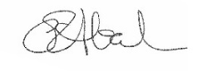

Christine Abraham
Chief Executive

